Model Data in Power BI
In this module you will learn:
- How to design a data model that is intuitive, high-performing, and simple to maintain
- You will learn about using the DAX language to create measures
- Those measures will help you create a wide variety of analytical solutions.
- Additionally, you will learn how to improve performance with your Power Query retrieval tasks

Introduction
Creating a great data model is one of the most important tasks that a data analyst can perform in Microsoft Power BI

A good data model offers the following benefits:
- Data exploration is faster
- Aggregations are simpler to build
- Reports are more accurate
- Writing reports takes less time
- Reports are easier to maintain in the future

Generally, a smaller data model is better because it will perform faster and will be simpler to use

Aim for simplicity when designing data models

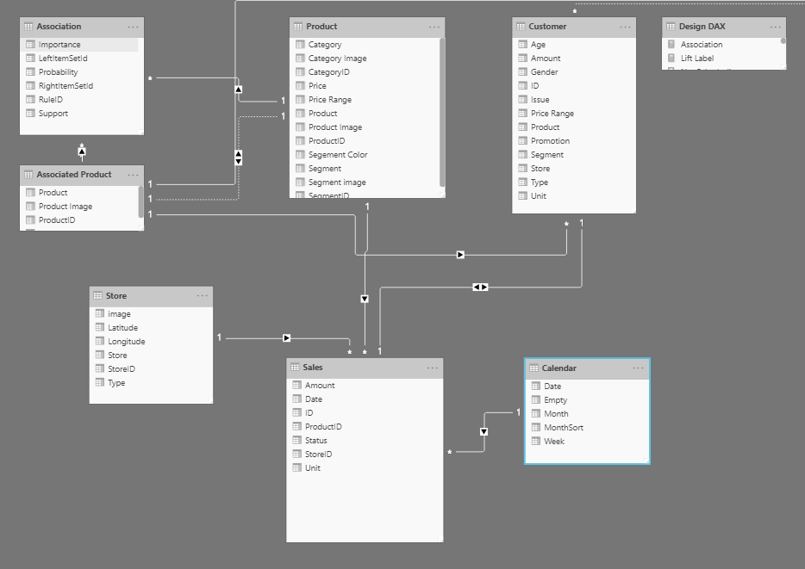
The above image is an example data model

Boxes contains tables of data
each line within the box is a column
lines that connects the boxes represent relationships between the tables

Relationships are defined between tables through primary and foreign keys

Primary Keys
Primary keys are columns that identify each unique, non-null data row.
A unique value for every single entry in the table
Each row is assigned a unique value, which can be referred to by this simple value

Foreign Keys
Values which references to rows in different tables

Relationships between tables are formed when you have primary and foreign keys in common between different tables.

Data Schema
The Basics of a Data Schema
Pulling one table from a relational database (SQL database) and Microsoft Excel file and creating a relationship between those two tables and treating them as a unified dataset

Star Schemas
designed to simplify your data. A popular method to simplify your data

In a star schema, each table within your dataset is defined as either a dimension or a fact table

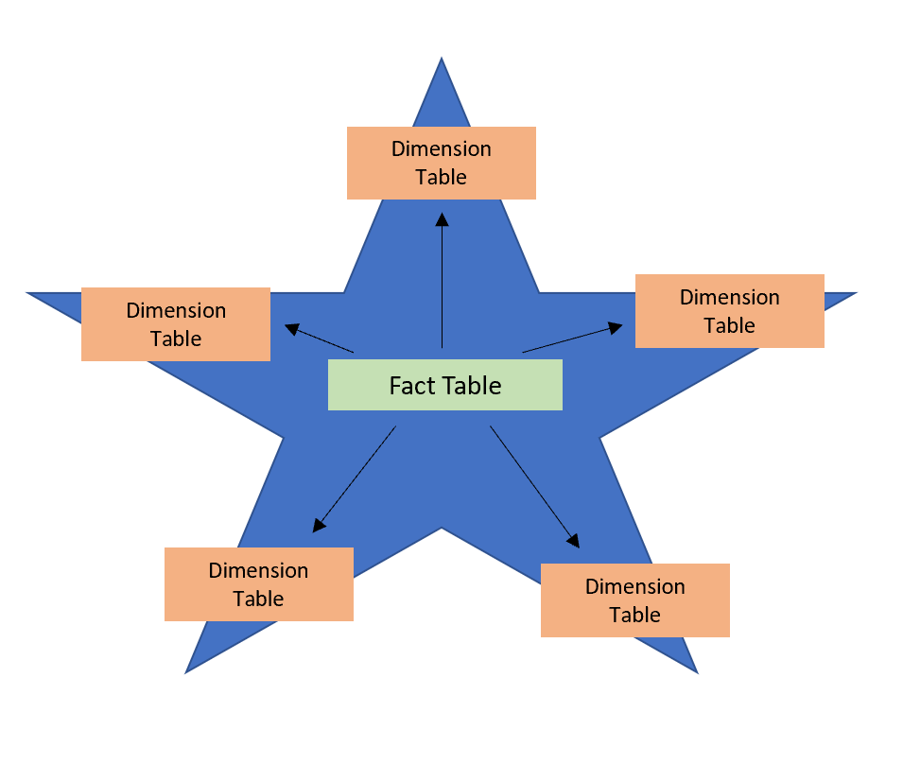

Fact Tables
contain observational or event data values
- sales orders
- product counts
- prices
- transactional dates and times
- quantities

can contain several repeated values

e.g., one product can appear multiple times in multiple rows, for different customers on different dates

These values can be aggregated to create visuals

e.g., a visual of the total sales is an aggregation of all sales orders in the fact table

with fact tables it is common to see columns that are filled with numbers and dates

An example fact table can be transactions database in an e-commerce website. Where it is common to see columns that are filled with numbers and sales. The numbers can be units of measurements, such as sale amounts, or they can be keys, such as customer ID. The dates represent that is being recorded, like order data or shipped date.

Fact tables are usually much larger than dimension tables because numerous events occur in fact tables, such as individual sales in a transaction database for an e-commerce website

Dimension Tables
contains the details about the data in the fact tables
- products
- customers
- locations
- employees
- order types

These tables are connected to the fact table through KEY COLUMNS.

Dimensions tables are used to filter and group the data in fact tables

The dimension tables, by contrast, contain unique values

for instance,
- one row for each product in the Products table
- one row for each customer in the Customer table

this data can be used to e.g.,
- total sales orders visual, you could group the data so that you see total sales orders by product, in which product is data in the dimension table.
Dimension tables are typically smaller because numerous events occur in fact tables, such as individual sales

An Example of A Fact Tables and Dimension Tables
A scenario:
Two tables exist – Employees and Sales

Sales – a fact table
contains the sales order values, which can be aggregated

Employees – a dimension table
contains the specific employee name, which filters the sales orders

The common column between the two tables, which is the primary key in Employees table, is EmployeeID

therefore we can establish a relationship between the two tables

Star schemas and the underlying data model are the foundation of organized reports.

Work with Tables
Users enjoy fewer tables to interact with – this is because data model and table structures are simplified

A simple table structure will:
- Be simple to navigate because of columns and table properties that are specifically and user-friendly
- Have merged or appended tables to simplify the tables within your data structures
- Have good-quality relationships between tables that make sense

ONLY ONE KEY RELATIONSHIP CAN EXIST BETWEEN TABLES

Configure Data Model and Build Relationships between Tables

The following image displays how relationships between Order and Sales table can be seen through the OrderDate column

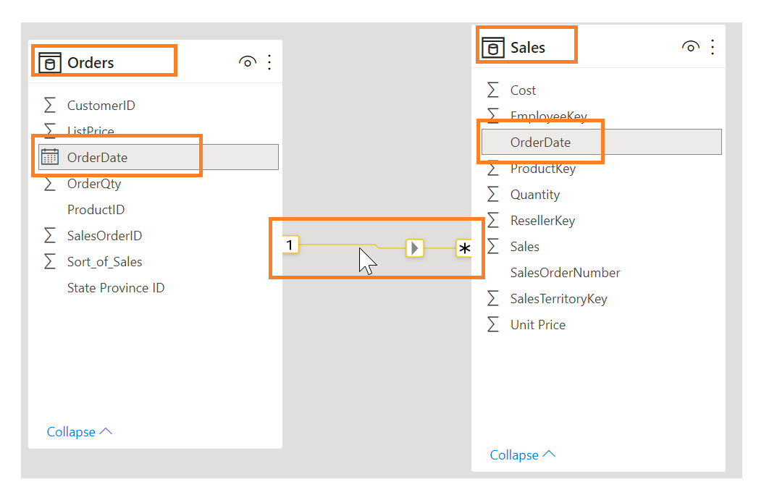
Assuming that you’ve already retrieved your data and cleaned it in Power Query,

you can then go to the Model tab, where the model is located

You can also view a complete list of relationships in the Manage Relationship button on the top ribbon => a window will pop-up that:

allows you to create, edit, and delete relationships between tables and also autodetects relationships that already exist

Autodetect Feature
help you establish relationships between columns that are named similarly

The Manage Relationship feature also allows you to configure relationships between tables, you can also configure tables and column properties to ensure organization in your table structure

Configure Table and Column Properties
The Model view in Power BI Desktop also provides options within the column properties that you can view or update

A simple method to get to this menu to update tables and fields is by Ctrl+clicking or Shift+clicking items on this page.

Under the General tab, you can:
- Edit the name and description of the column
- Add synonyms that can be used to identify the column when you are using the Q & A feature
- Add a column into a folder to further organize the table structure
- Hide or show the columns

Under the Formatting tab, you can:
- Change the data type
- Format the date

Under the Advanced tab, you can:
- Sort by a specific column
- Assign a specific category to the data
- Summarize the data
- Determine if the column or table contains null values

Power BI also allows you to update these properties on many tables and fields by Ctrl+clicking or Shift+clicking items

Create a Date Table

Making calculations based on date and time is a common business requirement

Organizations want to know how their business is doing over months, quarters, fiscal years, and so on.

The scenario:
Multiple tables, Orders and Sales, each contain their own date columns

Develop a table of the total sales and orders by year and month

How can you build a visual with multiple tables, each referencing their own date columns?

The SOLUTION: Create a common date table that can be used by multiple tables

Create a Common Date Table
Ways to build a common date table:
- Source data
- Data analysis expressions (DAX)
- Power Query

Source Data
Occasionally, source databases and data warehouses already have their own data tables

These tables can be used to perform the following tasks:
- Identify company holdings
- Separate calendar and fiscal year
- Identify weekends versus weekdays

Source data tables are mature and ready for immediate use

IF YOU HAVE A TABLE AS SUCH, bring it in into your data model, and USE IT

DAX
The DAX expression functions CALENDARAUTO() and CALENDAR() can be used to build a common date table

CALENDAR()
this function returns a contiguous range of dates based on a start and end data that are entered as arguments in the function

An example of the Calendar function to print the dates between January 1st 2020 to December 31st 2020 is:

Calendar = CALENDAR(DATE(2020, 1, 1), DATE(2020, 12, 31))

CALENDARAUTO()
this function returns a contiguous, complete range of dates that are automatically determined from your dataset

The starting date is the earliest date that exists in the dataset

The ending date is the latest date that exists in the dataset plus data that has been populated to the fiscal month that you can include as an argument in the CALENDARAUTO() function

An example of the CalendarAuto function being used is:

Dates = CALENDARAUTO()

Dates Columns
Dates column can be quite sparse. You can use the following DAX functions to see:

All of these functions are entered after clicking the New Column button on the Table Tools section
- the columns for just the year
Year = YEAR(Dates[Date])

- the month number
Month Number = MONTH(Dates[Date])

- the week of the year
Week Number = WEEKNUM(Dates[Date])

- the day of the week
DayOfTheWeek = FORMAT(Dates[Date], “DDDD”)

Mark as the Official Table
In order to mark the table as the official date table, find the table in the Fields pane
=> Right-click the name of the table
=> Select Mark as date table in the following figure

By marking this table as the official date table, Power BI performs validation to ensure that:
- data contains zero null values
- data is unique
- data contains continuous date values over a period

Selecting Mark as date table will also remove auto-generated hierarchies from the Date field

You can also manually add a hierarchy to the common data table by right-clicking the year, month, week, or day columns in the Fields pane and selecting New hierarchy

Building a Visual with the Official Date Table
In order to build a visual between two different tables using the Date table as the common table
=> You need to first
=> establish a relationship between this new common date table and the Sales and Orders tables
=> This will result in you being able to build visuals using the two tables

An example statistic is Total Sales and Order Quantity by Time visual
The DAX used for this calculation is:

#Total Sales = SUM(Sales[‘Amount’])

After you have finished, you can create a table by returning to the Visualizations tab and selecting the Table visual

In order to e.g., see the total orders and sales by year and month.
You include:
- Year column
- Month column
- OrderQty column
- #TotalSales measure column
in the visualization

Working with Dimensions
Just a reminder, when building star schemas you will have fact tables and dimension tables

Fact tables
contains information about events such as sales orders, shipping dates, resellers, and suppliers

Dimension tables
store details about business entities, such as products or time, and are connected back to fact tables through a relationship

Hierarchies can be used as one source to help you find detail in dimension tables.
Form through natural segments in the data

A hierarchy of dates can be segmented into years, months, weeks, and days

useful, as they allow you to drill down into specifics of your data instead of seeing the data at a high level

Hierarchies
The following pictures are the steps taken to create a hierarchy
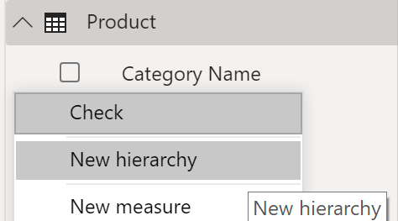

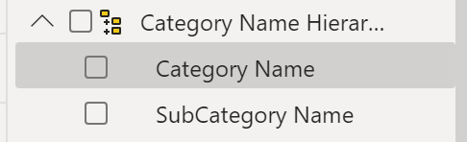

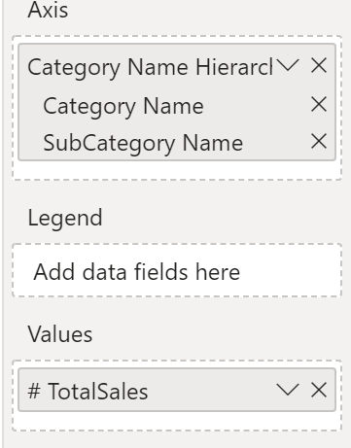

The result is then the following visualziation

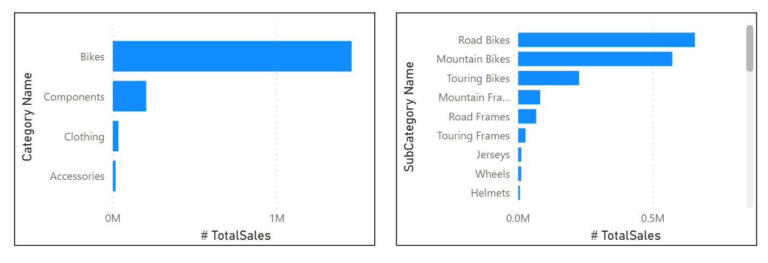
Hence, hierarchies allow us to view increasing levels of data on a single view

Parent-Child Hierarchy
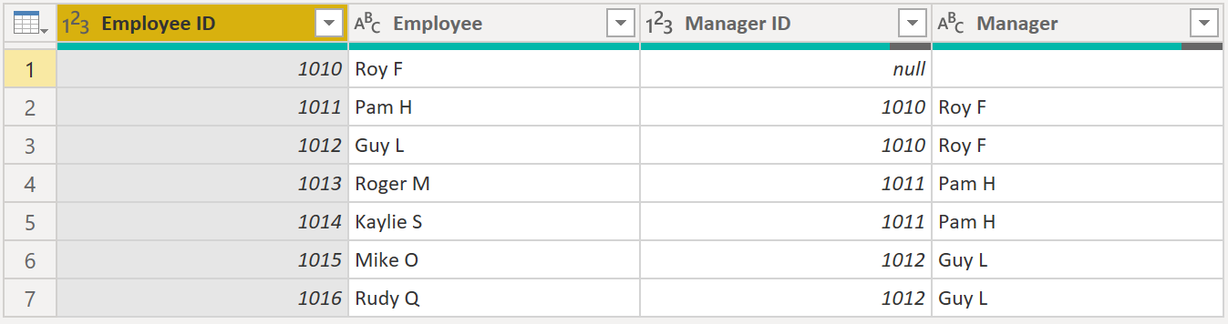
The above image is the scenario used to explain how parent-child hierarchy is used.

Roy F is continuously mentioned in the Manager column
this implies that there is a hierarchy between the Employee column and the Manager column

also, it is shown that multiple employees can have the same manager
this implies that the MANAGER is the PARENT and the EMPLOYEE is the CHILD in the hierarchy

We need to flatten the hierarchy in order to view more data granularity related to the hierarchy
basically each step of the hierarchy

Flattening the Parent-Child Hierarchy
The process of viewing multiple child-levels based on a top-level parent is known as flattening the hierarchy

you are creating multiple columns in a table to show the hierarchical path of the parent to the child in the same record

The following DAX functions will display the hierarchical path of the parent to the child:
- PATH() - a simple DAX function that returns a text version of the managerial path for each employee

ManagerEmployeePath = PATH(‘Employee’[EmployeeID], ‘Employe’[ManagerID])

- PATHITEM() - a DAX function that can separate this path into each level of managerial hierarchy

An example of executing this DAX function is shown below.
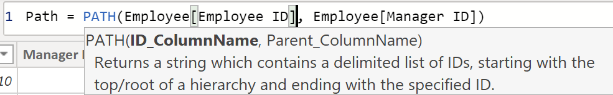
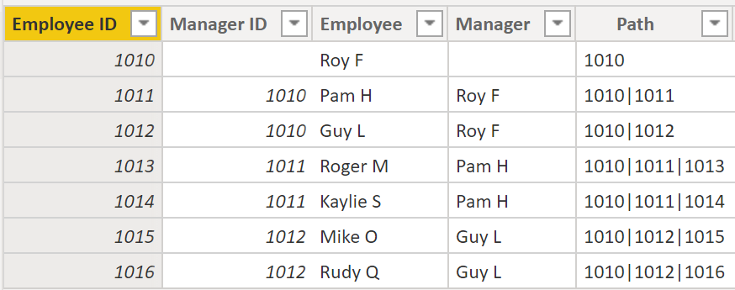
The Path results are read from left to right where
- the leftmost value denotes the parent
- the rightmost value denotes the child

In order to view all three levels of the hierarchy separately, you create four columns in the same way you did previously by entering the following equations.

Using the PATHITEM function to retrieve the value that resides in the corresponding level of your hierarchy

- Level 1 = PATHITEM(‘Employee’[ManagerEmployeePath], 1]
- Level 2 = PATHITEM(‘Employee’[ManagerEmployeePath], 2]
- Level 3 = PATHITEM(‘Employee’[ManagerEmployeePath], 3]

The resulting table then becomes:

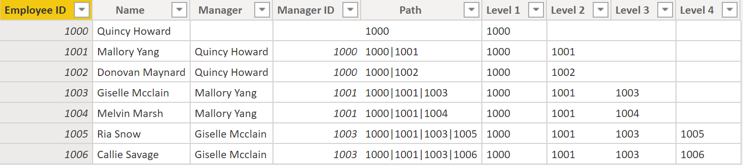
The hierarchy has now been flattened and we are now able to view individual levels

Role-Playing Dimensions
Role-playing dimensions have multiple valid relationships with fact tables, meaning that the same dimension can be used to filter multiple columns

As a result,

You can filter data differently depending on what information you need to retrieve

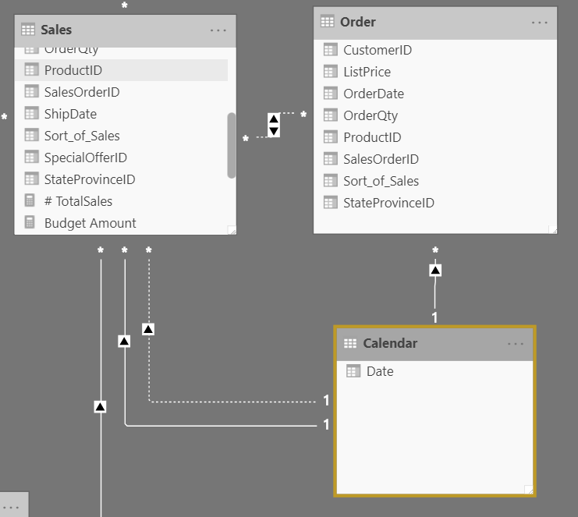

The above image displays how a role-playing dimension is expressed

the Calendar table can be used to GROUP DATA in BOTH SALES AND ORDER

If you wanted to build a visual in which the Calendar table references the Order and Sales table

the Calendar table would act as a role-playing dimension

Define Data Granularity
The detail that is represented within your data

meaning that the more granularity your data has, the greater level of detail within your data

Defining the correct data granularity can have a big impact on the performance and usability of your Power BI reports and visuals

An example scenario:
Tracking the temperature of 1,000 temperature controlled semi-trucks

How do you determine the granularity of this data (level of detail)?
- Daily average temperature of each truck? (1,000 rows)
- Last recorded temperature (1,000 rows – last value of sensor)
- Temperature records that are above and below a normal range of temperatures (could be 1,000+ or < 1,000 depending on the performance of the temperature control)

Determining the level of granularity is dependent on the business case and scenario

The MAIN GOAL:
- Bring data that is comprehensive and valuable
  - e.g., settle for weekly, monthly, or quarterly data.
  - The fewer the records, the faster the reports and visuals will respond
  - Faster refresh rate for the entire dataset, allows you to refresh more frequently

The MAIN DRAWBACK:
- If your users want to drill into every single transaction, summarizing the granularity will prevent them from doing that – a negative impact on the user experience

Important to negotiate the level of data granularity with report users so they understand the implications of these choices

Data Granularity to Build a Relationship between Two Tables
Differing levels of data granularity could lead to problems:

e.g., lowest-level of time-based detail in the Sales tables is by day, e.g., 5/1/2020, 6/18/2020
however,
the lowest-level of time-based detail in the Budget tables is by month, e.g., 5/2020 and 6/2020

These different levels of granularities NEED TO BE RECONCILED before you can build a relationship between tables

A solution could be:
Defining a new table column that matches with the granularity of the selected table

e.g., reformatting two column headers (Year and Month Number) to a tertiary Date column that combines them using M
an example M query language could be:

Column = Table.AddColumn(#”Renamed Columns”, “Custom”, each [Year] & “-” & [Month])

This fix should allow you to create a relationship between the Budget and Calendar tables

Create a Relationship between Tables
In general, Power BI automatically detects relationships, but you can also go to

Manage Relationships => New, and create the relationship on a specified column between multiple tables.

The relationship should resemble the following.
This also ensures that the granularity is the same between the different tables

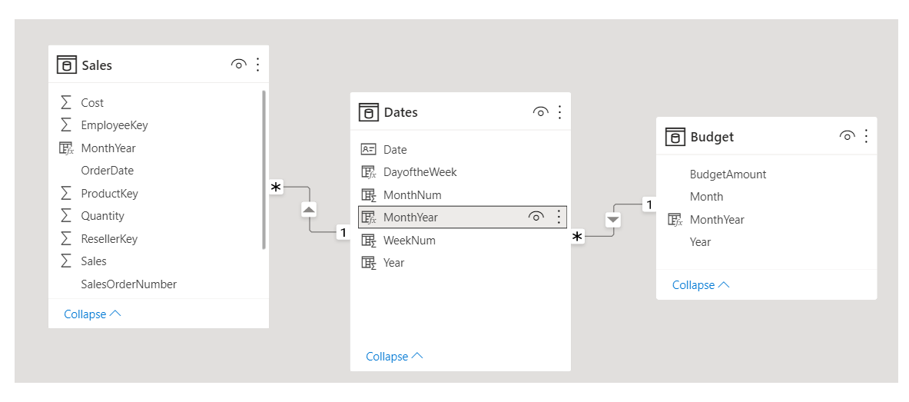
Work With Relationships and Cardinality
Power BI has the concept of directionality to a relationship

Directionality plays an important role in filtering data between multiple tables

Power BI automatically looks for relationships that exist within the data by matching column names

You can also use Manage Relationships to edit these options manually

An example visualizing the different auto-detected relationships
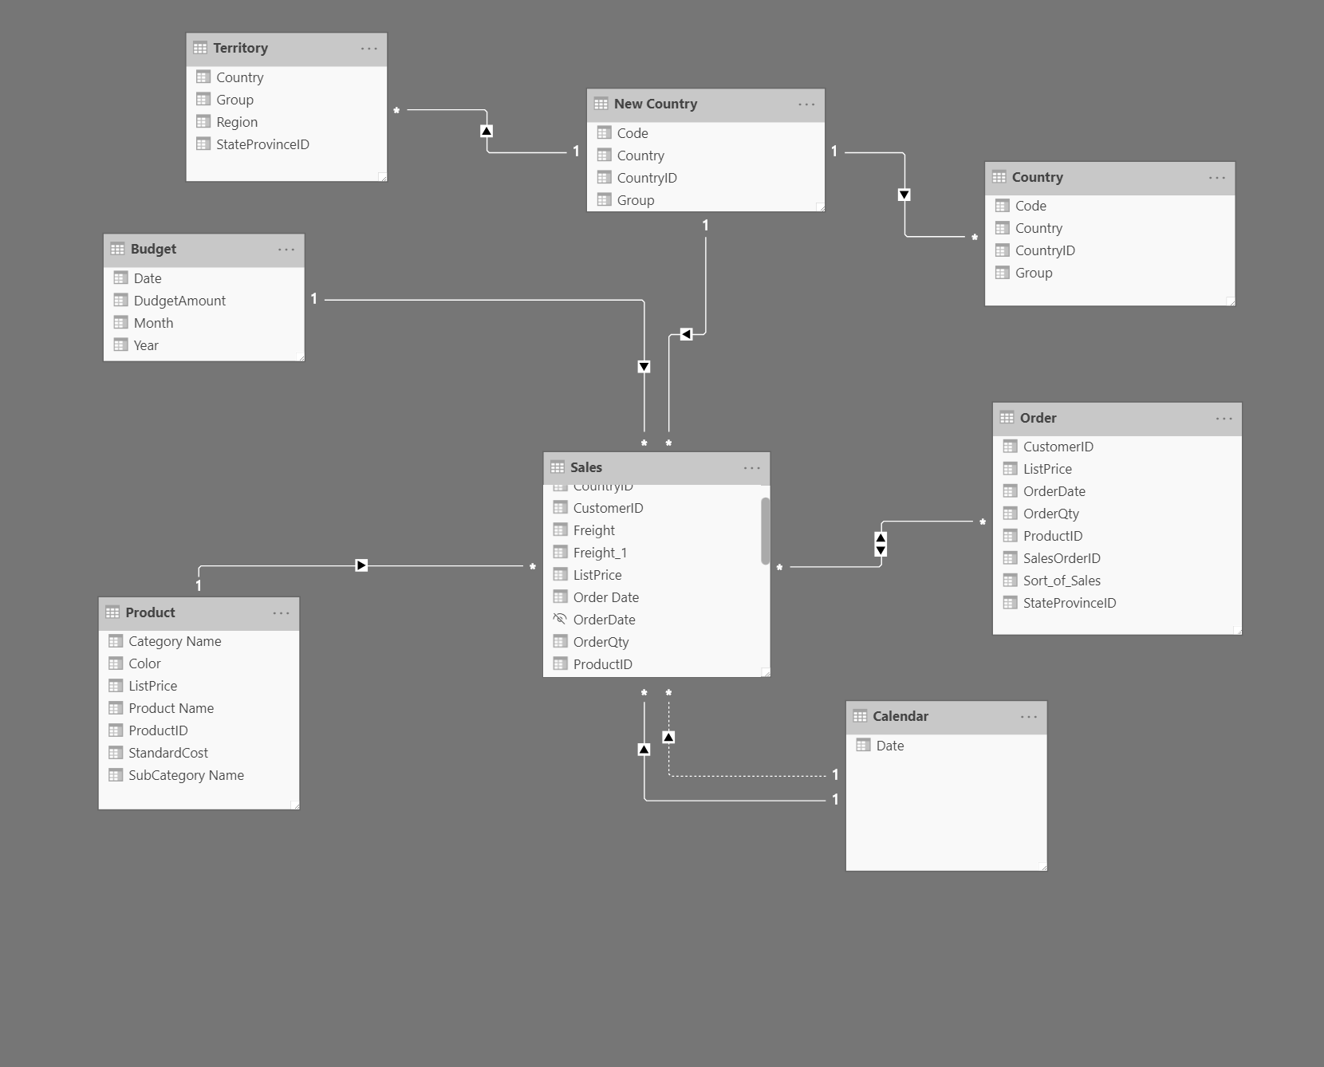

Relationships
The following are different types of relationships in Power BI:

- Many-to-one (* : 1) and one-to-many (1 : *) relationships
  - A relationship where you have many instances of a value in one column that are related to only one unique corresponding instance in another column
  - Describes the directionality between fact and dimension tables
  - Most common type of directionality and is the Power BI default when automatically creating relationships

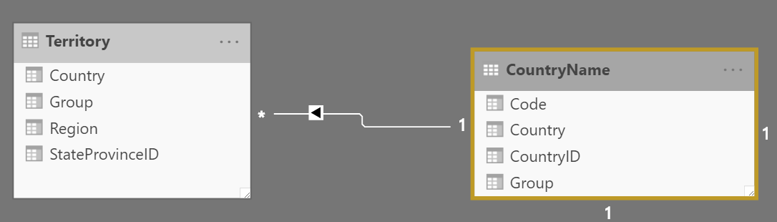
The above is an example of a one-to-many relationship.
Where you can have many territories being associated with one country

- One-to-one (1 : 1) relationships
  - a relationship where there are only one instance of a value is common between two tables
  - Requires unique values in both tables

This is NOT RECOMMENDED because this relationship stores redundant information and is not designed correctly

The ideal solution:
Merge/combine the two tables – as both tables have unique values

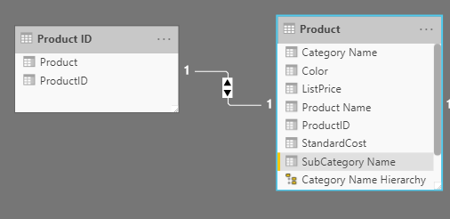
The above is an example of one-to-one relationship.
A product and productID table. This is redundant – the table should just be combined

- Many-to-many (.) relationships
  - A relationship where many values are in common between two tables
  - Does not require unique values in either table

NOT RECOMMENDED: a lack of unique values introduces ambiguity – users might not know which column of values is referring to what.

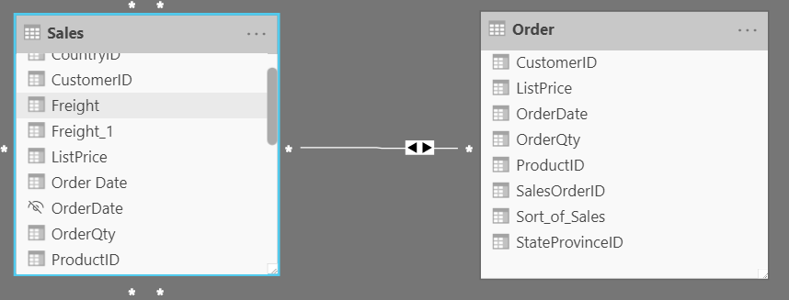
The above displays a many-to-many relationship between the Sales table and the Order table on the OrderDate column
This is very ambiguous as both tables can have the same order date – duplicate / the same orders explored in both tables

Cross-Filter Direction
Data can be filtered on one or both sides of a relationship

With a single cross-filter direction:
- Only one table in a relationship can be used to filter the data
  - e.g., Table 1 can be filtered by Table 2, but Table 2 cannot be filtered by Table 1

You typically want these arrows to point to your fact table

For a one-to-many or many-to-one relationship, the cross-filter direction will be from “one” side meaning that the filtering will occur in the table that has many values

Basically the filter propagate from the “one side” to the “many side”,
in an example case, filters applied to the Products table will propagate to the Sales table
but NOT in the opposite direction

Cross-Filter directions or Bi-directional Cross-Filtering
An example:
One table in a relationship can be used to filter the other. A dimension table can be filtered through the fact table and the fact table

Hard to do, try to avoid this if you are unsure of what to do

Resolve Modelling Challenges
Modelling data is about establishing and maintaining relationships so that you can effectively visualize the data in the form that your business requires

When creating relationships, a common pitfall is circular relationships

e.g.,
Table 1 has a many-to-one relationship with a column in Table 2, but Table 2 has a one-to-many relationship with Table 3 that ALREADY HAS its own relationship with Table 1

Web of relationship is difficult to manage and becomes a daunting task to build visuals. As it is no longer clear what relationship exists.

Identify circular relationships so that data is usable

Relationship Dependencies
Dependencies on either column values or separate tables will lead to changes in corresponding queries and calculations if the column / table that it was dependent on were to be changed

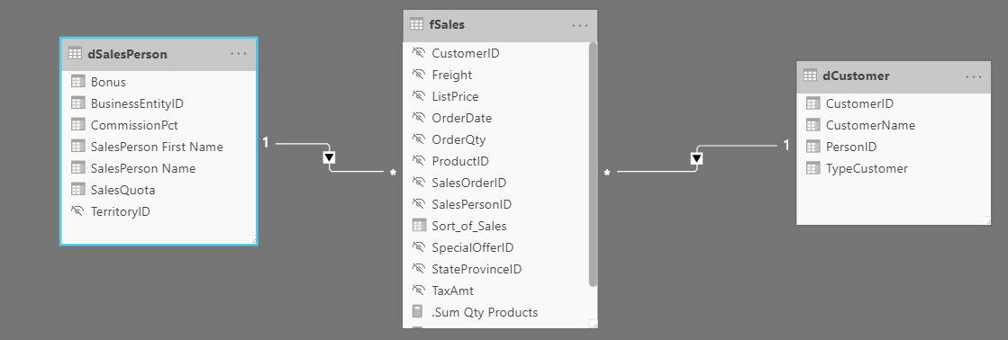
Consider the above relationship.
As,

Sales[‘TotalCost’] = Sales[‘Quantity’]*Sales[‘Price’]

TotalCost depends on Quantity and Price
hence,
If a change occurs in either quantity or price then a change will also occur in TotalCost aswell

Quick-Measures***
A quick measure creates the calculation formula for you
- Easy
- Fast
to create for simple and common calculations

You can also create basic measures (calculations using DAX) on columns easily.

You can do this by, in the Data view, select a table in the Field table
=> Right-click the selected table and select new quick measure

You can select a range of basic calculations/measures that include:
- Totals
- Time intelligence
- Filters
- Aggregate per category

calculations

ALL OF THE ABOVE CALCULATIONS WITHOUT USING DAX

Bulk Update Properties
You are able to update multiple columns using single bulk updates

You can use this to
- hide columns
- format column values

Hidden Columns
Can be because they’re used by relationships or will be used in row-level security configuration or calculation logic

